**REACT**

**Day-10 20-12-2022 T SREE SOWMYA**

**CSE-04 IV YEAR**

**221910304044**

**Life cycle of React components:**

**Mounting:**

**Component didMount():**

import './App.css';

import {useState} from 'react';

import Gitamhyd from './Gitamhyd';

import Student from './Student';

//import User from './User'

import React,{Component} from 'react';

import GitamSowmya from './GitamSowmya';

class App extends React.Component

{

    constructor()

    {

        super();

        console.warn("Constructor");

    }

    componentDidMount()

    {

     console.warn("DidMount");

    }

    render()

    {

     console.warn("Render");

     return(

    <div>

    <h1>example for ComponentDidMount</h1>

    </div>

     );

    }

}

export default App;

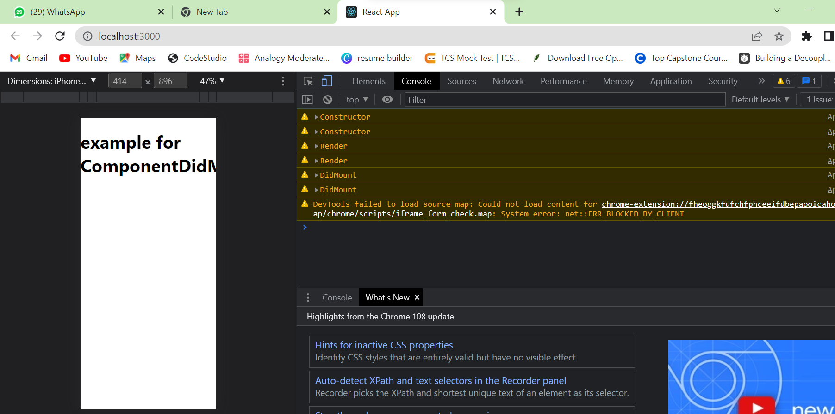

**Didupdate doesnot work here:**

import './App.css';

import {useState} from 'react';

import Gitamhyd from './Gitamhyd';

import Student from './Student';

//import User from './User'

import React,{Component} from 'react';

import GitamSowmya from './GitamSowmya';

class App extends React.Component

{

    constructor()

    {

        super();

        console.warn("Constructor");

    }

    componentDidMount()

    {

     console.warn("DidMount----22191000");

    }

    componentDidUpdate()

    {

    console.warn("Component Did Update -sowmya")

    }

    render()

    {

     console.warn("Render");

     return(

    <div>

    <h1>example for ComponentDidMount</h1>

    </div>

     );

    }

}

export default App;

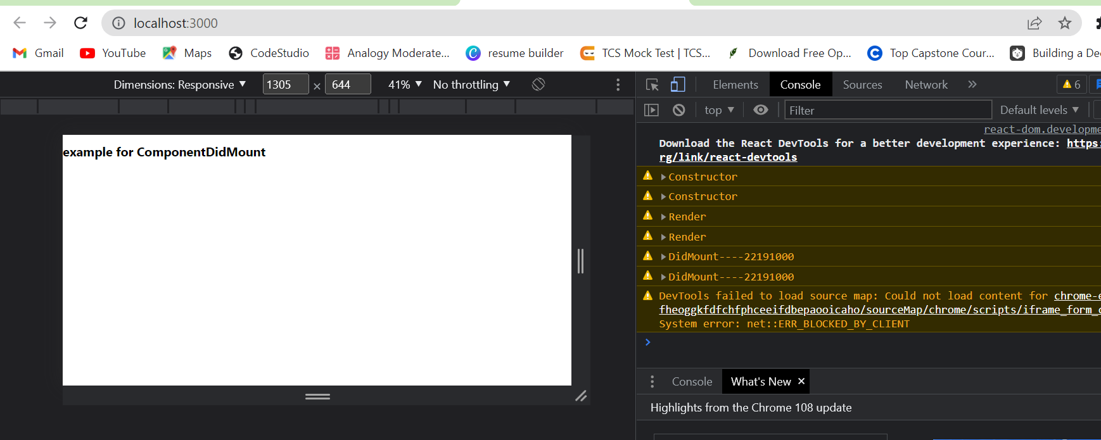

**Didupdate:**

import './App.css';

import {useState} from 'react';

import Gitamhyd from './Gitamhyd';

import Student from './Student';

//import User from './User'

import React,{Component} from 'react';

import GitamSowmya from './GitamSowmya';

class App extends React.Component

{

    constructor()

    {

        super();

        console.warn("Constructor");

        this.state={

            count:0

        }

    }

    componentDidUpdate(preProps,preState,snapshot)

    {

     console.warn("componentDidUpdate",preState.count,this.state.count);

    {

     alert("data is already same")

    }

    }

    render()

    {

     return(

    <div>

    <h1>example for ComponentDidUpdate{this.state.count}</h1>

    <button onClick={()=>{this.setState({count:1})}}>Update Value</button>

    </div>

     );

    }

}

export default App;

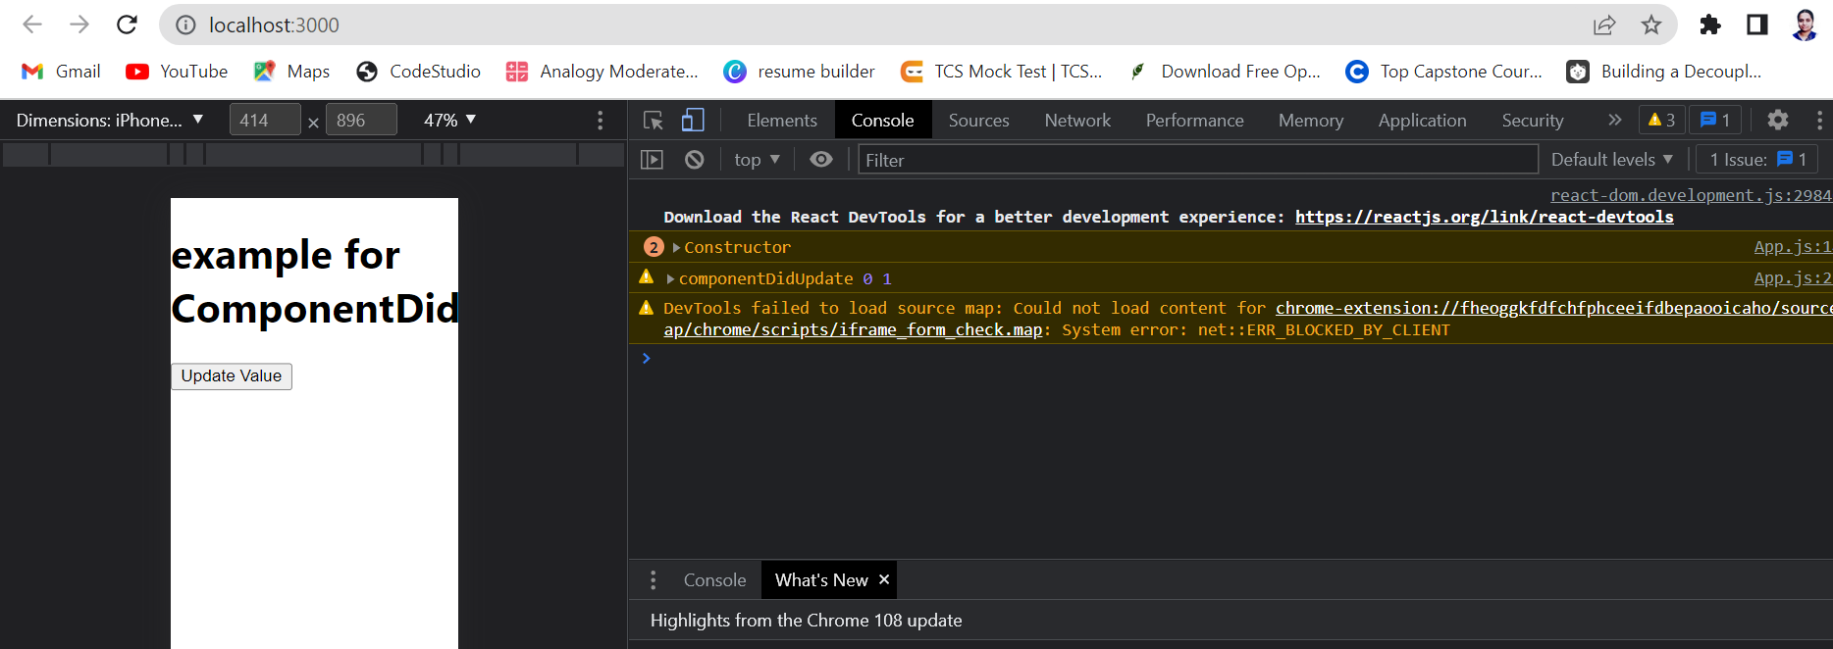

**ShouldComponentUpdate:**

**Function is true:**

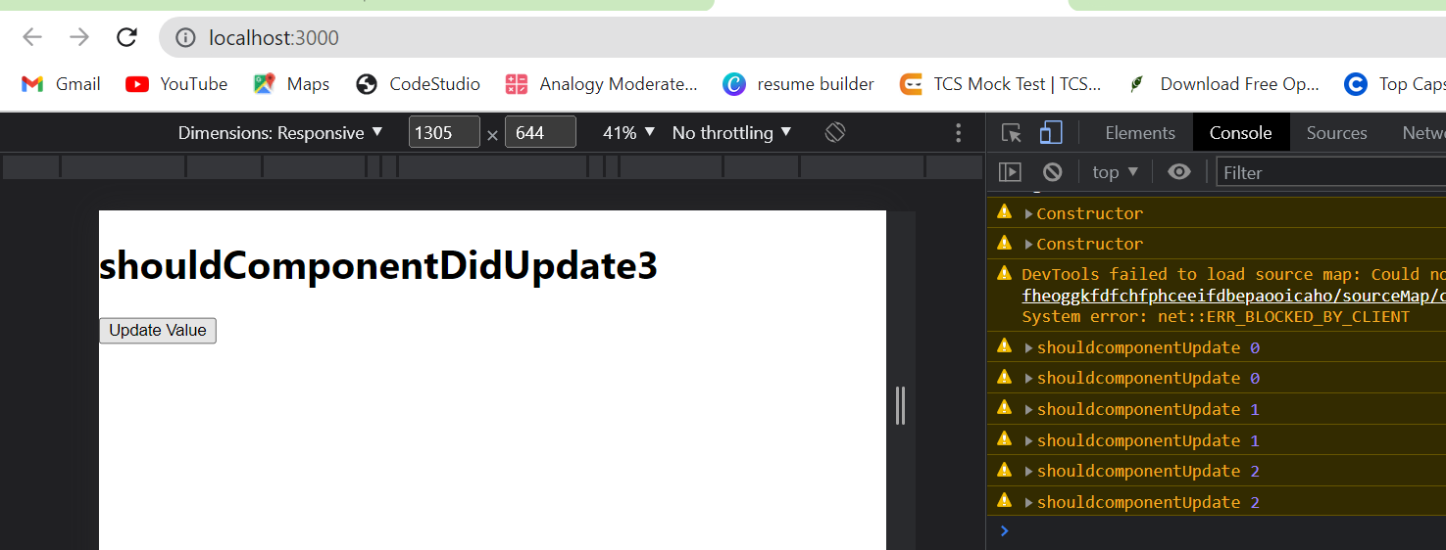

**Second case:**

import './App.css';

import {useState} from 'react';

import Gitamhyd from './Gitamhyd';

import Student from './Student';

//import User from './User'

import React,{Component} from 'react';

import GitamSowmya from './GitamSowmya';

class App extends React.Component

{

    constructor()

    {

        super();

        console.warn("Constructor");

        this.state={

            count:0

        }

    }

    shouldComponentUpdate(preProps,preState,snapshot)

    {

     console.warn("shouldcomponentUpdate",this.state.count);

    return false;

    }

    render()

    {

     return(

    <div>

    <h1>shouldComponentDidUpdate{this.state.count}</h1>

    <button onClick={()=>{this.setState({count:this.state.count+1})}}>Update Value</button>

    </div>

     );

    }

}

export default App;

**should component function we return false:**

**so in website -🡪 no updation seen**

**in backend 🡪 updatiom observed**

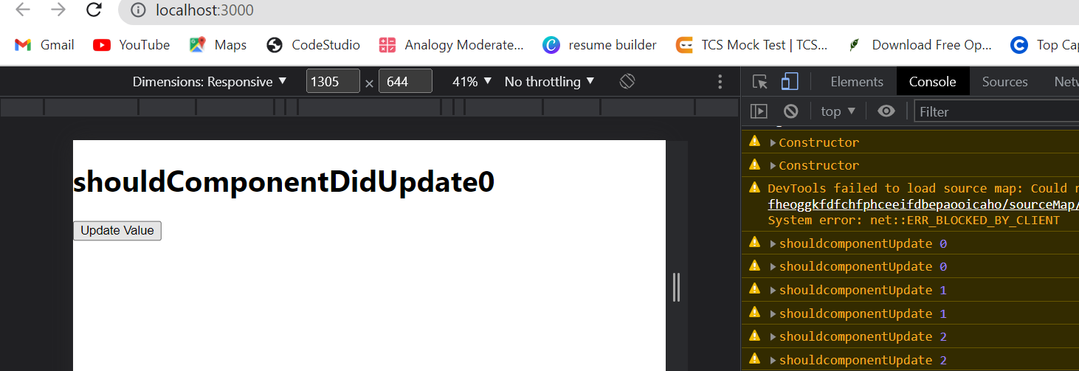

**Create a class component , in that class component create a state called “increase” and assign initial value =”5”, create a button with your name , so whenever you r clicking on that button the value of “increase” should jump to 10 ,Consider the method “ShouldComponentUpdate “ in that method it has to display “hello “ and present value of “increase”**

import './App.css';

import {useState} from 'react';

import Gitamhyd from './Gitamhyd';

import Student from './Student';

//import User from './User'

import React,{Component} from 'react';

import GitamSowmya from './GitamSowmya';

class App extends React.Component

{

    constructor()

    {

        super();

        console.warn("Constructor");

        this.state={

            increase:5

        }

    }

    shouldComponentUpdate(preProps,preState,snapshot)

    {

     console.warn("Componentshould--Hello ",this.state.increase);

    return true;

    }

    render()

    {

     return(

    <div>

    <h1>HEllo !! {this.state.increase}</h1>

    <button onClick={()=>{this.setState({increase:this.state.increase+5})}}>Sowmya</button>

    </div>

     );

    }

}

export default App;

